Project Planning Phase
Project Planning Template (Product Backlog, Sprint Planning, Stories, Story points)

Date | 15 February 2025
Team ID | LTVIP2026TMIDS66355
Project Name | Laptop Request Catalog Item
Maximum Marks | 5 Marks

Product Backlog, Sprint Schedule, and Estimation (4 Marks)
Use the below template to create product backlog and sprint schedule
Sprint | Functional Requirement (Epic) | User Story Number | User Story / Task | Story Points | Priority | Team Members
Sprint-1 | User Registration | USN-1 | User registers by entering basic details in the portal | 2 | High | Team
Sprint-1 | Login | USN-2 | User logs in using email ID and password | 1 | High | Team
Sprint-2 | Laptop Request | USN-3 | User submits laptop request with required details | 2 | Medium | Team
Sprint-1 | Approval Process | USN-4 | Manager and IT team approve laptop reques | 2 | Medium | Team
Sprint-1 | Request Tracking | USN-5 | User checks request status and updates | 1 | Low | Team
Sprint-2 | Notifications | USN-6 | System sends email updates about request status | 2 | Medium | Team

Project Tracker, Velocity & Burndown Chart: (4 Marks)
Sprint | Total Story Points | Duration | Sprint Start Date | Sprint End Date (Planned) | Story Points Completed (as on Planned End Date) | Sprint Release Date (Actual)
Sprint-1 | 20 | 6 Days | 24 Oct 2022 | 29 Oct 2022 | 20 | 29 Oct 2022
Sprint-2 | 20 | 6 Days | 31 Oct 2022 | 05 Nov 2022 | 20 | 13 Mar 2026
Sprint-3 | 20 | 6 Days | 07 Nov 2022 | 12 Nov 2022 | 20 | 20 Mar 2026
Sprint-4 | 20 | 6 Days | 14 Nov 2022 | 19 Nov 2022 | 20 | 27 Mar 2026

Velocity (Management Asset Portal)
Imagine we have a 10-day sprint duration for the Laptop Request Catalog Item , and the velocity of the team is 20 (points per sprint). Let’s calculate the team’s average velocity (AV) per iteration unit (story points per day).
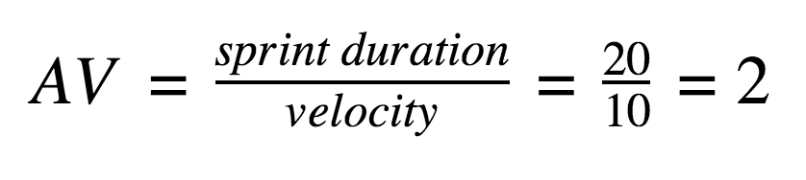

Burndown Chart(Laptop Request Catalog Item):
A burndown chart shows the remaining work over time in the Laptop Request Catalog Item project. It helps track request form development, approval workflow progress, and task completion. This chart ensures the project stays on schedule and helps teams monitor progress efficiently.
https://www.visual-paradigm.com/scrum/scrum-burndown-chart/
https://www.atlassian.com/agile/tutorials/burndown-charts
Reference:
https://www.atlassian.com/agile/project-management
https://www.atlassian.com/agile/tutorials/how-to-do-scrum-with-jira-software
https://www.atlassian.com/agile/tutorials/epics
https://www.atlassian.com/agile/tutorials/sprints
https://www.atlassian.com/agile/project-management/estimation
https://www.atlassian.com/agile/tutorials/burndown-charts

